Your Christmas Survival Guide

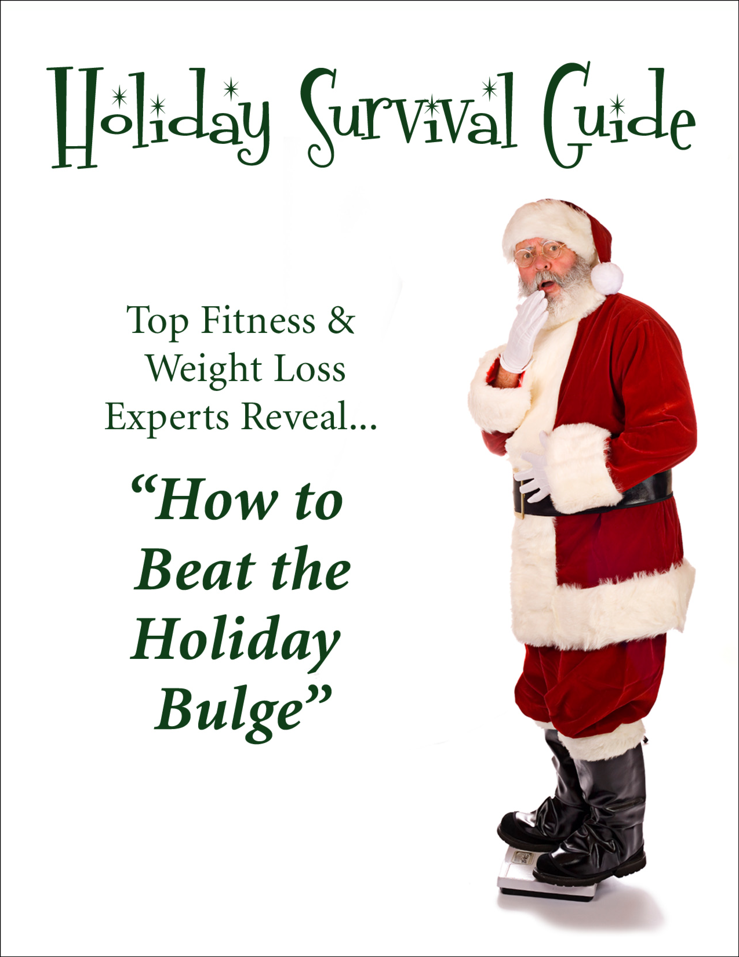

Christmas Survival Guide

Written by Lincoln Bryden

©Lincoln Bryden September 2020.

All rights reserved. Without limiting the rights under copyright reserved above, no part of this publication may be reproduced, stored or introduced into a retrieval system, or transmitted, in any form or by any means (electronic, photocopying, recording or otherwise), without the prior written permission of the copyright owner of this manual.

IMPORTANT COPYRIGHT & LEGAL NOTICE:

You Do NOT Have The Right To Reprint, Resell, Auction or
Re-distribute 28 Day Quick Start Guide E-book!
You May NOT give away, sell, share, or circulate The Burn The
Fat, Feed The Muscle E-Book or any of its content in any form!

The copy of 28 Day Quick Start Guide you have purchased is for your own personal use. The e-book is fully printable and one printed copy may be made for your own personal use. You are also welcome to copy the e-book to a CD-Rom, Zip disc or other storage media for backup for your own personal use.

Electronic books, also known as e-books, are protected worldwide under international copyright and intellectual property law, the same as printed books, recorded material and other literary works. Under Copyright law, "Literary Work" includes "computer", "computer program", "software", and all related materials sold online, including electronic books (e-books), and adobe acrobat PDF files. Copyright infringement, trademark infringement and theft of intellectual property are serious crimes.

MEDICAL DISCLAIMER
This program is for educational and informative purposes only and is not intended as medical or professional advice. Always consult your doctor before making any changes to your fitness regime. The purpose of this program is to help healthy people reach their cosmetic fitness goals by educating them in proper exercise guidelines. No health claims are made for this program. This exercise program will not help cure, heal, or correct any illness, metabolic disorder, or medical condition. The author is not a medical doctor, registered dietician, or clinical nutritionist; the author is a fitness consultant.

If you have been sedentary and are unaccustomed to vigorous exercise, you should obtain your physician’s clearance before beginning an exercise program. The American College of Sports Medicine (ACSM) recommends that apparently healthy individual who are male and over 40 or female and over 50 to have both a physical exam and a diagnostic exercise test prior to starting a vigorous exercise program.

A diagnostic exercise test and physical examination is also recommended in individuals of any age who exhibit two or more of the major coronary risk factors (smoking, family history of heart disease, elevated blood cholesterol, elevated blood pressure, and diabetes). Any individual with a known history of heart disease or other heart problems should be required to have a medical evaluation including a graded exercise test before engaging in strenuous physical activity.

The author and publisher shall have neither liability nor responsibility to any
Person or entity with respect to any of the information contained in this manual. The user assumes all risk for any injury, loss or damage caused or alleged to be caused, directly or indirectly by using any information described in this course.

Your Christmas Survival Guide – A New Direction Fat Loss Coaching

“Come on live a little! It’s the holidays!”
“Who cares if it’s bad for you…it tastes so good!”
“So what if I pack on 10 lbs during the holidays? I’ll just diet and exercise the pounds off after the New Year!

Do any of these lines sound familiar? Of course they do and I am sure that each and every one of us has iterated one of the above comments or have made other related statements at some point in our
lives. For some reason we feel entitled to this bingeing-type mentality during the holiday season.

“So what if I pack on 10 lbs during the holidays? I’ll just diet and exercise the pounds off after the New Year!”

A bite of a mince pie here, an extra helping of pudding there... It all seems so innocent at the time.
But as the calorific Christmas extravaganza continues apace, it might be worth bearing in mind that any extra helpings could still be clinging to your thighs and tummy in March.

A study has found that extra pounds we pile on over the festive period will take a depressing three months to shift.
According to research by MSN, for Christmas lunch alone the average Brit feasted on two to three servings, consuming 2,300 calories across one meal.

That accounts for 115 per cent of the recommended daily intake for women, and 92 per cent for men - and that's before taking into account the nuts, chocolates and alcohol we consume.
Now I am not here to say not to indulge over Christmas as I know that this is a very important time to spend with family and friends and to de stress from a difficult year. What I am going to detail in this report are things that you can do to enable you to hit the ground running for 2013 rather than rolling!
I am going to detail some food choices that you can adopt outside of your festive meals so that you have as much choice of keeping the weight off as possible. Then I will be sharing a 20 minute program that you can either do in the gym or at home.

There are a bunch of handy damage control diet strategies that you should employ to best prevent yourself from overdoing it at the dinner table this holiday season. Use the tips below to allow yourself to stay social and to be able to indulge in moderation without splitting your pants before the New
Year:

1.) Perform High-Intensity Activity Before and/or After a Big Meal or Holiday Feast

I know, I know. I promised diet strategies, but I simply cannot go without recommending some activity. Your body is most receptive to higher calorie and/or carbohydrate meals within 30 minutes before and within three hours following high-intensity activity. Ideally you would want to work out before AND after a big meal, but if you can only do one, that will suffice. It is less important when you do it and more important that you do it. Your best options will be 20 minutes of circuit resistance training or cardio interval training. Even a 20-30 plus minute walk a few hours afterwards can serve as a bit of damage control.

2.) Do NOT Gorge Yourself

Eat until the point of satisfaction, not discomfort. Remember this: binge eating is not the habit of lean individuals. It is imperative to understand that holiday meals are not a ticket to eat as much as you can in as little time as possible. However, listen to your body and make sure to enjoy the foods you are
craving in moderation and only eat when you are hungry.

3.) Eat a High-Fibre, Protein-Rich Meal an Hour before a Holiday Event

A meal high in fibre and protein before a big holiday meal will help prevent overeating by making you feel more full which in turn means less calories consumed during the ensuing feast.

4.) Eat Leans Proteins and Fruits and Vegetables FIRST

Just because it’s a holiday meal doesn’t mean you can’t eat any nutritious food. Make sure to load up on healthier food choices first and try to eat as much lean meat, fish, and fruits and veggies as possible at the start of each holiday event. This will leave less room for the unhealthier, higher calorie treats. At least this way you know your body is getting in some good nutrition.
.
5.) Drink, Drink, Drink Water!

Water competes for space in your stomach and truly helps decrease appetite. For every plate you eat, try to drink at least 1-2 glasses of water. After that second plate, when you have 1 full litre of water in your stomach, I bet you might just throw in the towel!

6.) Do NOT Eat Again Until Hungry Following a Large Meal

Now I know I already told you to eat every 2-4 hours, but there is one exception to this. If you eat a huge meal, it is important not to eat again until you are hungry and/or no longer full. If your body is not used to eating such a big meal, then it will take a much longer time to digest all that food and the worst thing you can do is put more food into an already full stomach. Only when you are hungry again should you resume your normal eating plan following a big holiday meal.

7.) Use Lower Calorie/Carbohydrate Substitutes Whenever Possible

Instead of using sugar, opt for zero calorie alternatives like splenda or stevia. They can deliver a similar taste without all of the extra sugar and calories. Even try replacing yeast with protein powder when you bake. The extra protein and reduced carbohydrates will result in a slimmer you while still providing some great tasting treats! Your goal should be to find the minimal amount of calories that can provide the same great taste that makes the holiday treats enjoyable rather than simply overdoing it because you can!

8.) Avoid Eating Meals that are High in Both Fat and Carbohydrates

The absolute worst thing that you can do is to eat a meal that is high in both fat and carbs. The high amount of carbs will lead to a rapid increase in blood sugar levels and thus large increases in the potent fat-storing hormone Insulin. The high amount of fat will lead to a large increase in free fatty acids in your bloodstream. Since Insulin is already present in large amounts, in addition to there being a large amount of free fatty acids now available in your blood, the stage is set for all those free fatty acids to be gobbled
up and stored by your fat cells.

But since most people crave carbs at their free meals, it is essential to keep the fat low at this meal. Want pasta? Instead of alfredo sauce, opt for marinara sauce with whole grain pasta. Want pizza? Make your own pizza with whole grain crust and fat-free cheese. Want mashed potatoes? Well
then be sure to skip the gravy and go easy on the butter. These small changes can literally save you hundreds, even thousands of calories, and more importantly will prevent your holiday feasts from creating the optimal fat-storing environment that will set you back from achieving your health and fitness goals.

Your Food Choices

So as well as your delicious Christmas dinner and other good stuff, it is important that we learn to redefine your nutrition choices so that we can get your body to burn fat, rather than store it. Sometimes when you start a program like this you may feel that there is a problem in getting creative with your food choices, as there may be the thought that you have to restrict your foods.

This is so not the case as there are loads of delicious breakfasts, lunches and snacks that you can have that are not boring and will provide enough variety during this process.



Breakfast Options

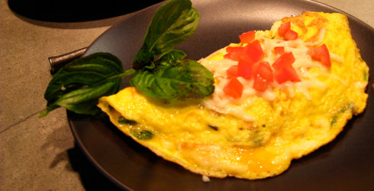

Breakfast Examples:

The aim of breakfast: To get a high protein breakfast with essential healthy fats coming from foods loaded with vitamins and minerals that will sustain energy levels throughout the day, give you balanced blood sugar levels to make fat loss effective, and to drastically reduce cravings throughout the day. We especially want to keep carbohydrates low in this circumstance.

Here are 7 breakfasts you can make.

-4 egg omelette with peppers, onion and tomato
2-4 Scrambled eggs and smoked salmon
2-4 Poached eggs and smoked salmon
Mackerel/sardines, tomato, onions and pepper stir fry on a bed of lettuce and spinach leaves
On the go breakfasts - when time is limited
- 4 egg whites, 1/2 cup spinach leaves, 1/2cup blueberries and rasperries, 1/8 cucumber (blend contents and drink on the go)
- 20g Whey protein with 300ml almond/rice milk with an avocado blended together
- 2-3 boiled eggs with vegetable sticks (celery, pepper, carrot) with almond butter.
- 1-2scoops of protein powder in 400ml water with 1 tablespoon almond butter or coconut butter
- Tinned mackerel or sardines with some nuts
Breakfast Smoothies
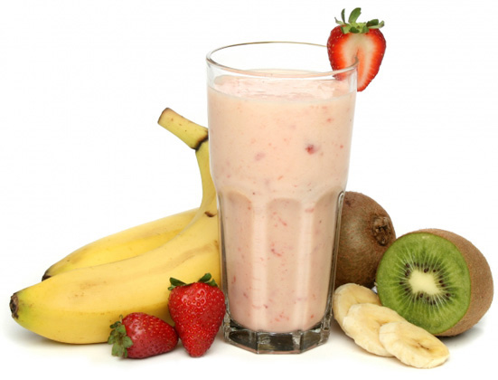
Blue Bomber Smoothie

• 1 scoop Isolate Protein
• ½ cup Greek yogurt
• 1/3 cup Almond Milk
• 1scoop Green drink
• 1 cup frozen blueberries
• 1 teaspoon coconut oil/extra virgin olive oil
• 1 cup water
• 5 ice cubes

DIRECTIONS
1. Blend and Enjoy!

The Thermacino
• 1 scoop Isolate Protein
• 1 teaspoon coconut oil/extra virgin olive oil
• ¼ cup of almond milk/rice milk
• 1scoop Green drink
• ¼ cup of water
• 2 teaspoons Organic Ground coffee
• ¼ cup of Greek yogurt
• Pinch of stevia
• Pinch of cinnamon
• 5 ice cubes

DIRECTIONS
Blend and Enjoy!
Chocolate Orange Mint Smoothie
• 1 scoop Whey Isolate chocolate Protein
• 1 teaspoon coconut oil/extra virgin olive oil
• ¼ cup of almond/rice milk
• 1scoop Green drink
• 1 Orange
• 1 cup of water
• 1 teaspoon mint
• 1 teaspoon basil/parsley
• Pinch of stevia
• 1 small square of grated 70% plus cocoa dark chocolate
• 5 ice cubes

DIRECTIONS
Blend and Enjoy!

Key Lime Smoothie

• 1 scoop Isolate Protein
• 1 teaspoon coconut oil/extra virgin olive oil
• 1cup of water
• 1scoop Green drink
• 1 Whole lime
• ½ cup full fat cottage cheese
• 1 banana
• 1 cup of spinach and kale mixed
• ½ cup of cucumber
• 5 ice cubes

Strawberry Vanilla Smoothie

• 1 scoop Strawberry Whey Isolate Protein
• 1 teaspoon coconut oil/extra virgin olive oil
• ¼ cup of almond/rice milk
• 1 scoop Green drink
• 1 cup of water
• 6 big frozen strawberries
• 5 ice cubes
• 1 /4 cup of Greek yoghurt

DIRECTIONS
Blend and Enjoy!

Almond Joy Smoothie
• 1 scoop Whey Isolate Protein
• 1 teaspoon coconut oil/extra virgin olive oil
• ¼ cup of almond/rice milk
• 1 scoop Green drink
• 1 cup of water
• 5 ice cubes
• 4 egg whites
• 1 teaspoon almond nut butter/handful of chopped almonds
• Dash of cinnamon

DIRECTIONS
Blend and Enjoy!

Lunch Examples

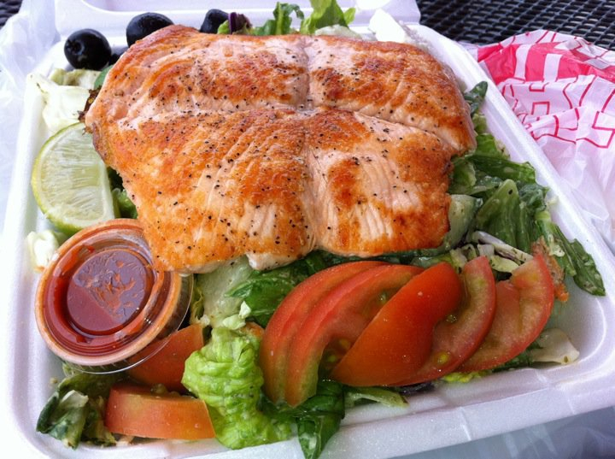

The aim of lunch – To sustain a good start to the day and make sure the body gets some sort of green vegetables in your meal plan. If green vegetables are a factor for you then a green drink is an absolute must for you at this stage to have with your meal. Protein must be the core of your meal and remember to cook with coconut butter, butter, or extra virgin olive oil. Coconut butter is best. This will provide healthy essential fats that the body need to continue the fat burning phase

- Homemade bolognaise with a small sweet potato cooked in butter
- Homemade chilli with vegetables
- Chicken curry with quinoa
- Tuna and egg salad dressed win balsamic vinegar
- Lemon and Italian herb salmon fillet with broccoli, asparagus, ½ an avocado, cauliflower, carrots
- Turkey steak seasoned with chilli and jalapeno’s with mixed leaf salad with ½ an avocado and olives
- Chicken breast marinated with course grain mustard with steamed vegetables
- Garlic and chilli Prawn salad
- Tinned sardines or mackerel on a side salad
- Smoked salmon and egg salad
- Protein shake with goats milk
- Chicken teriyaki with steamed vegetables
- Finely cuts steak/chicken slices, peppers, onions, and homemade salsa sauce wrapped in lettuce leaves
- Homemade quiche with steamed vegetables
Dinner Examples

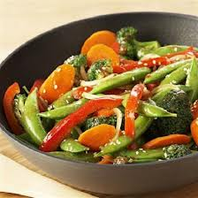

The aim of dinner – Ideally you would eat dinner at least two hours before bed. We want to aim to be settling down to bed by 10am where possible as later than that can bring about cortisol response which is the last thing we want for sleep. Protein is again the foundation of your plan and you want to accompany that with green vegetables and other vegetables. A colourful plate is the ideal solution.
- Steak and sweet potato wedges with a creme crèche peppercorn sauce
- Beef stir fry
- Garlic and lemon Seabass fillet with steamed green veg
- Salmon fillet in a tomato, onions, Italian herb and basil sauce with sweet potato mash
- Teriyaki Tuna steak with garlic green cabbage, asparagus, green beans
- Homemade bolognaise sauce with turkey/beef mince on a bed of lettuce leaves and thyme sprinkled on top. With a side dish vegetable dish of carrots, avocado, and asparagus
- Smoked cod and sweet potato wedges dressed with lemon and balsamic vinegar
- Chicken breast stuffed with hallumi cheese and chilli served on a bed of Mediterranean vegetables
- Sweet potato wedges with chicken breast with a peri peri sauce and green beans, broccoli and carrot
- Homemade quiche with steamed vegetables

Snack Examples

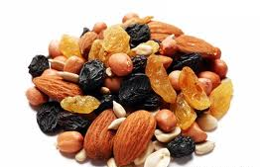

It is important to ALWAYS be prepared to have a mid-morning and mid afternoon snack to maintain your energy levels and to prevent ourselves from overeating at the next meal. Sometimes life takes a quick turn and forces you to require something quick and on the go, so I want you to always prepare by having one or more of the following available..

Snack Shopping List
- Nut butter
- Protein Bars
- Organic Almonds/cashews
- Organic nut butter (cashew/almond/hazelnuts)
- Gluten free oatcakes
- Celery/carrott/cucumber sticks to dip into nut butter
- Organic Blueberries
- Organic almonds/cashews with organic blueberries

Daily – walk 30 – 60 minutes, or as much as possible

Supplements List


The idea of these supplements is to detox your body, but mainly to provide it with the nutrients that it needs to rid the body of toxins which will allow the body to use fat for energy. If you need sources of where you can get these supplements then please do not hesitate to contact me on lincolnb@fitnesstrainingdownloads.com

These are the supplements I would recommend;
- 1 tablespoon Omega 3 oil with your breakfast, lunch and dinner
- 1 teaspoon/scoop Green detox powder in water (1 mid morning and 1 mid afternoon) if getting the right amount of green vegetables in your diet is going to be an issue
- 1 scoop Whey Protein added to your breakfast shake or after a workout
- A good quality mutivitamin

Your Leftover Turkey Recipes

We have all been there. Christmas dinner has been and gone and now you have all of these leftovers. So what I have done is included in this survival guide a list of some really easy recipes that you can add so that you do not reach for the family sizes quality streets!

Turkey and Ham Salad
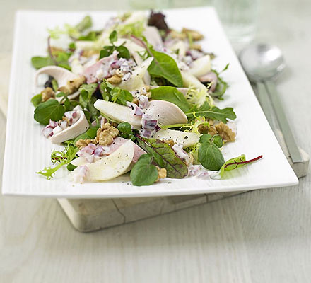

- Tip the bag of salad onto a large platter. Quarter, core and slice the pears, and roughly chop the walnuts. Scatter the pears and walnuts over the salad leaves. Cut the turkey and ham into strips and scatter over the top.
- Mix together all the dressing ingredients in a small bowl, then drizzle over the salad just before serving.

Make it meat free
Replace the turkey and ham with 100g sliced chestnut mushrooms, 100g cooked peas or green beans and 50g shaved parmesan.

Sherried Turkey and Ham Bake

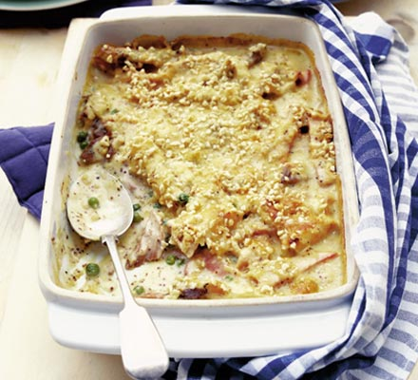

- Preheat the oven to 200C/Gas 6/fan oven 180C. Mix the turkey, ham and frozen peas in a buttered ovenproof dish.
- To make the sauce, put the butter, flour and milk in a saucepan and bring to the boil, whisking all the time, until the sauce is thickened and smooth. Stir in the sherry and mustard, season to taste and simmer for 1 minute. Remove from the heat and stir in half the cheese.
- To finish the dish, pour the sauce over the ingredients in the dish. Mix the remaining cheese with the nuts and sprinkle on top. At this point, you can keep the bake in the fridge up to 5 hours, or freeze it. When ready, bake for 25-35 minutes until the topping is golden and the sauce is bubbling.

Coronation Turkey

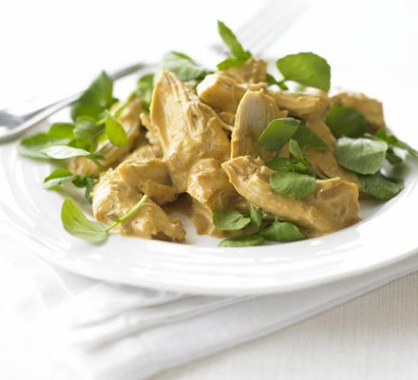

- Fry the onion in a little oil. Add the curry paste, tomato purée and wine to the onion and cook for two minutes.
- Stir in the apricot purée, mayo and cream and then fold in the turkey. Serve with watercress.

Turkey and Tarragon Pot Pie

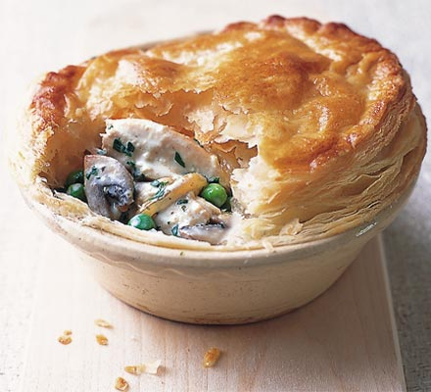

Heat the oven to 200C/fan 180C/gas 6. Cook the onion and mushrooms in a little butter until soft, add the rest of the ingredients (except the pastry), bubble up and season. Divide between 4 small ovenproof pie dishes, cover with a circle of puff and glaze. Bake for 20-25 minutes until puffed and golden.

Turkey and Lime Burgers

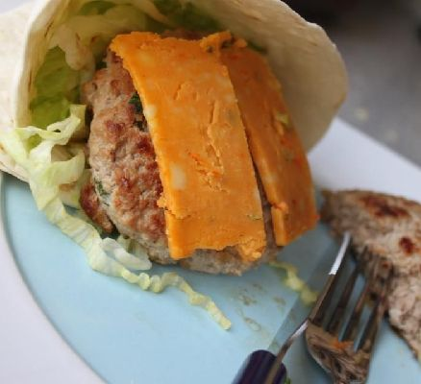

- Place minced turkey in a mixing bowl and add the lime zest, onion, garlic, coriander, cumin, paprika and chilli flakes.
- Once mixed thoroughly, add the lime juice and salt and pepper and mix until all the juice has been absorbed. They will be slightly wet but this is ok.
- Shape the mixture into 4 patties. You can make them any size you want so the number of patties is subjective.
- Heat the oil in a heavy based frying pan on a medium high heat. Once temperature had increased, add the burgers and cook for 5 minutes on each side until cooked all the way through. Place a slice of mexican cheese on top of the burgers whilst they are cooking so the cheese melts over the top.
- Heat the fajitas as per pack instruction. To make a pocket for the burgers, fold in half and then half again. Stuff the pocket with lettuce and add the burger when cooked. Serve with sour cream

Turkey and Avocado Toast

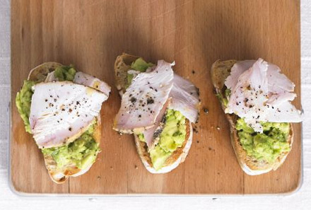

Halve and stone the avocado then scrape out the flesh into a bowl. Squeeze in the lime, season, then mash roughly with a fork. Toast the ciabatta, spread with mashed avocado, top with turkey and finish with ground black pepper.

Turkey and Parsnip Curry

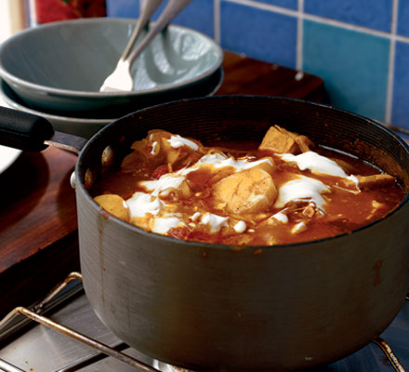

- Heat the oil in a saucepan, add the onions and fry gently for 10 minutes until they are softened and lightly coloured. Add the parsnips and stir well.
- To make the curry, stir in the curry paste, then add the tomatoes with a little salt, and stir well. Add 1½ canfuls of water and bring to the boil. Reduce the heat, cover and simmer for 15-20 minutes, until the parsnips are just tender.
- To finish, stir in the turkey chunks, cover the pan again and simmer for a further 5 minutes until the turkey is heated through. Remove from the heat. (The curry can now be cooled and frozen for up to 2 months.) Lightly swirl in the yogurt and serve with basmati rice.

Your Exercise workout Overview

Day1 - Monday 1 x Metabolic Resistance Training (MRT)
workout
Day2 - Tuesday High Intensity Interval Training 20 – 30 mins
Day3 - Wednesday 1 x MRT
Day4 -Thursday High Intensity Interval Training 20 – 30 mins
Day5 - Friday 1 x MRT
Day6 - Saturday Optional Cardio
Say7 - Sunday REST

REPEAT THIS SEQUENCE FOR AS MANY WEEKS AS YOU CAN (AIM FOR 6) WHILST FOLLOWING A FAT LOSS NUTRITION PLAN

I have wanted to make this as easy for you as possible so that you did not have to remember so many elements as possible. So you will learn your bodyweight workout, plan your nutrition program and then repeat these elements.

The workout can be done either in a gym, or at home, so you have no excuse ☺

Your High Intensity Interval Training Workout

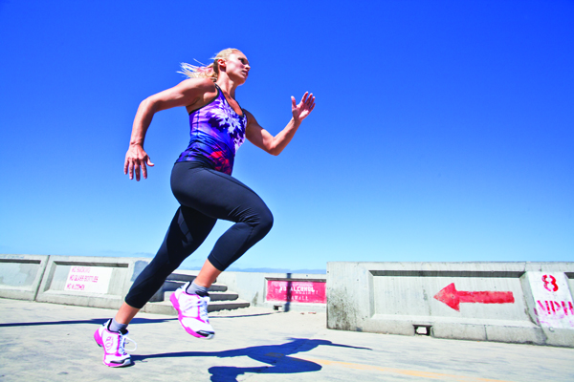
HIIT is a training idea in which low to moderate intensity intervals are alternated with high intensity intervals.
HIIT can be applied to running or to exercises such as squatting. HIIT is considered to be much more effective than normal cardio because the intensity is higher and you are able to increase both your aerobic and anaerobic endurance while burning more fat than ever before.
"In research, HIIT has been shown to burn adipose tissue more effectively than low-intensity exercise - up to 50% more efficiently." It has also been shown to speed up your metabolism which helps you burn more calories throughout the day.
The following is a typical interval workout. Choose your exercise equipment, eg exercise bike, cross trainer, stepper, etc. You alternate the same period of low intensity with the same period of higher intensity.
1. 3 - 5 minutes warmup
2. 1 minute moderate or high intensity eg 7-8/10 if 1 being really easy and 10 being extremely hard )followed by 1 minute low intensity at intensity of 3-4/10 (repeat 5 times in week 1, 6 times in week 2, 7 times in week 3 and 8 times in week 4)
3. 3 - 5 minutes cooldown (light jog, low intensity, gradually decreasing by the end of the cooldown period)

Your Fat Loss Workout

Body weight warm up. –

Repeat for 3 circuits. Perform each exercise for 16 reps

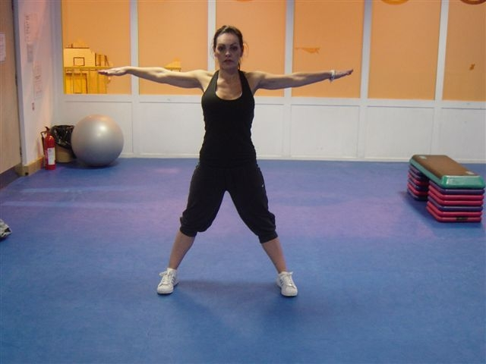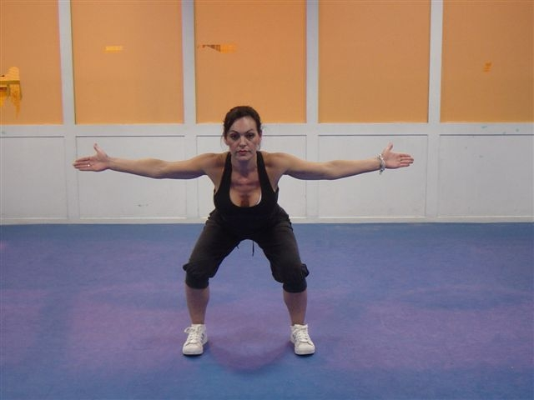 T squat

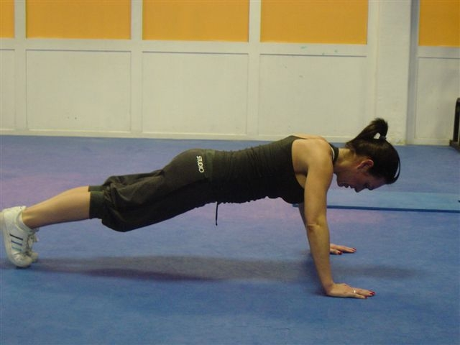 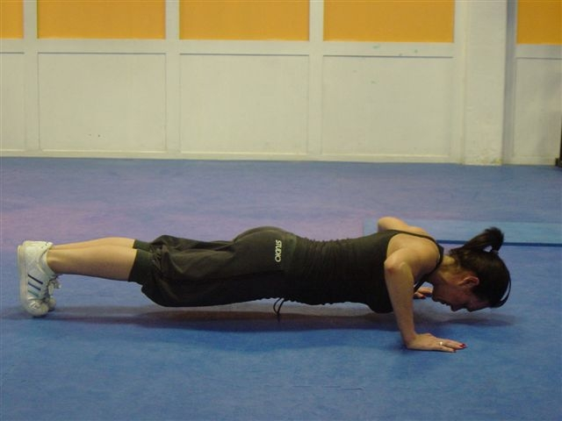 push up (go down onto your knees if you
need to)

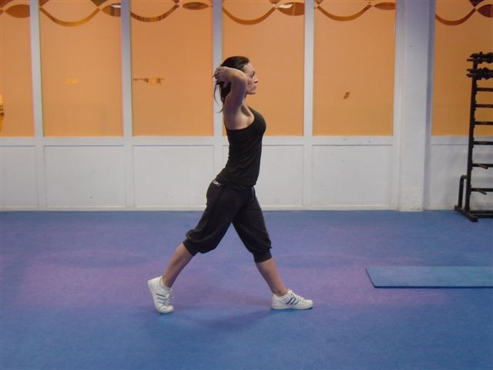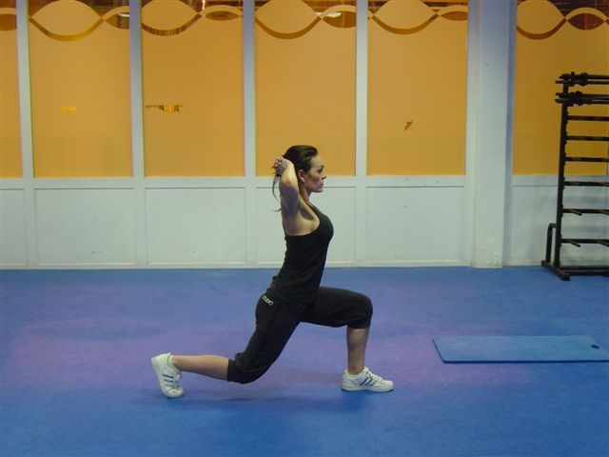 split squats

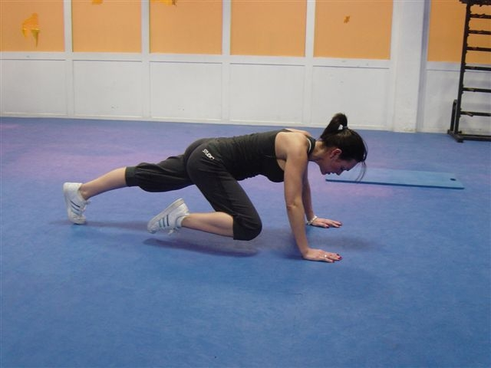 spiderman climbs

Your Metabolic Resistance Training Workout

 | Week 1 |  |  |  | Week 2 |  |  |  | Week 3
Mini Circuit A | Set 1 | Set 2 | Set 3 |  | Set 1 | Set 2 | Set 3 |  | Set 1 | Set 2 | Set 3
A1 Single Legged Deadlift (10 each Leg)
A2 Push Ups x 12
A3 Switch Jumps 30 secs
Mini Circuit B
B1 Reach Lunge (12 each leg)
B2 T Push Up (8 each side)
B3 Squat Runs (30 Seconds)
Mini Circuit C
C1 Side Lunge and touch (12 reps each side)
C2 Plank walk up (8 reps)
C3 Jumping Jacks (60 seconds)

Perform each circuit as a mini workout, 1 exercise after the next. So for Mini Circuit A you would perform exercise A1, then A2 then A3, that would be one circuit. I would suggest for week 1 perform 1 circuit, week 2 perform 2 circuits and weeks 3 and 4 perform 3 circuits of each mini circuit.

Exercise Descriptions

Mini Circuit A

Single leged deadlift
A great hip extension exercise. From a standing position, flex from the knee and the hip to touch the floor. Hold this position for a couple of seconds then repeat for the desired number of repetitions

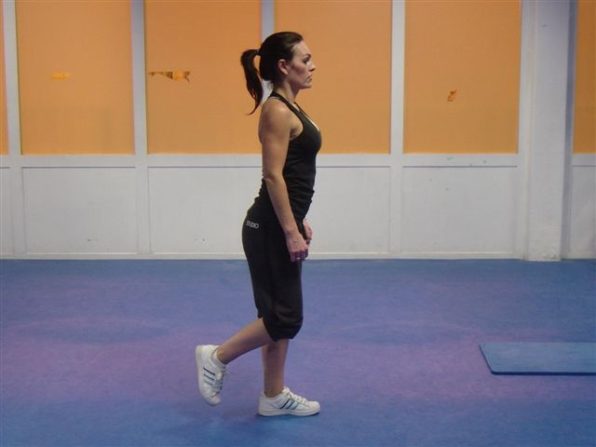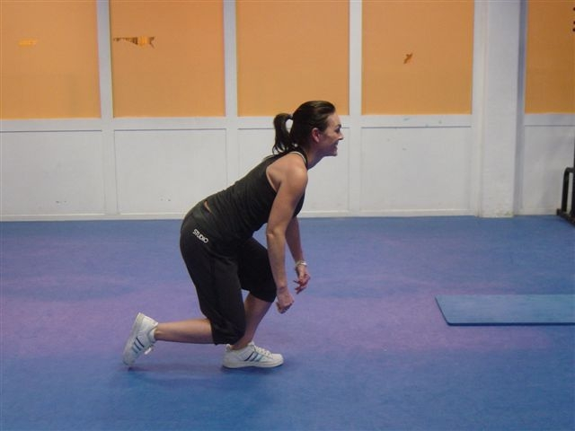

Push Ups

Keep the abs braced and body in a straight line from toes/knees to shoulders. Place the hands on the floor slightly wider than shoulder-width apart. Slowly lower yourself down until you are 2 inches off the ground. Push through your chest, shoulders and triceps to return to the start position. Keep your body in a straight line at all times

Switch Jumps

Step your left leg back into a lunge and bring your arms in front of you. Push off the ground, swinging your arms up to the ceiling, and switch your legs in the air, landing in a lunge with your left leg forward. Continue switching legs as quickly as you can for 30 seconds.

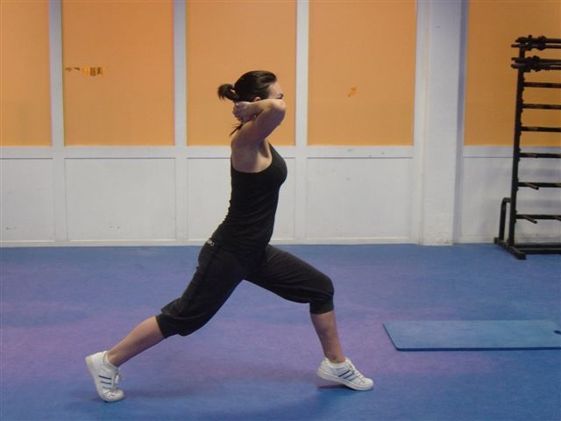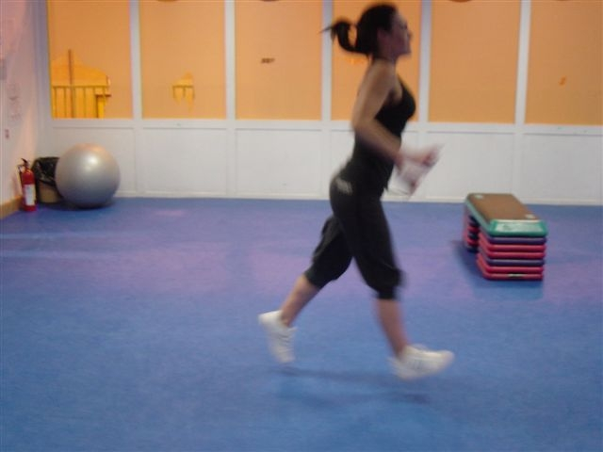

Mini Circuit B

Lunge and touch

From a standing position lunge either forwards, to the side or backwards, aiming to touch the floor. Make sure the back is straight and knees flex to protect the lower back

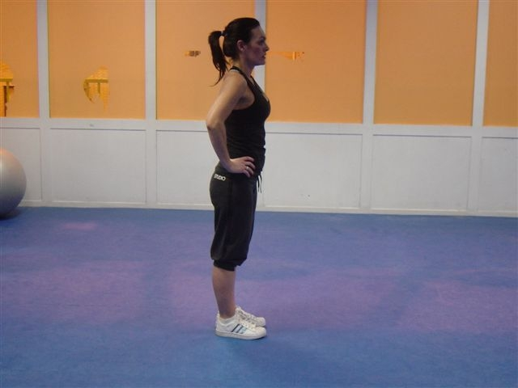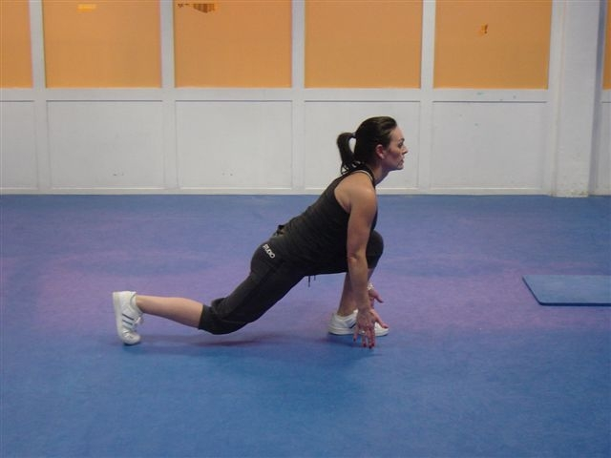

T Push Ups

In between each push up, rotate the body so that you form a T shape. Again this is a great exercise for the core as well as developing shoulder stability and upper body strength

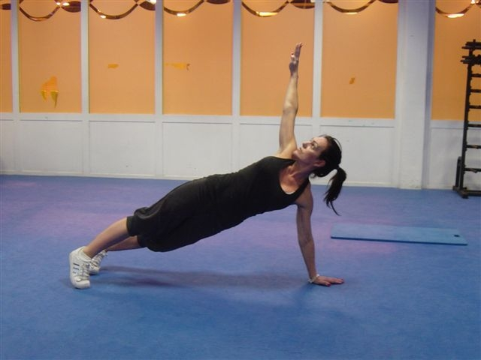

Squat Runs

Mountain climbers begin in a plank position, with your hands in line with your shoulders and your legs extended while you balance on the balls of your feet. Push through your legs and pull your right knee in toward your chest and let your foot land on the ground. Quickly switch legs, pushing your right leg back and driving your left knee in toward your chest. Continue to switch at a quick pace for 30 to 60 seconds.

Mini Circuit C

Side Lunge and touch

From a standing position lunge to the side, aiming to touch the floor. Make sure the back is straight and knees flex to protect the lower back

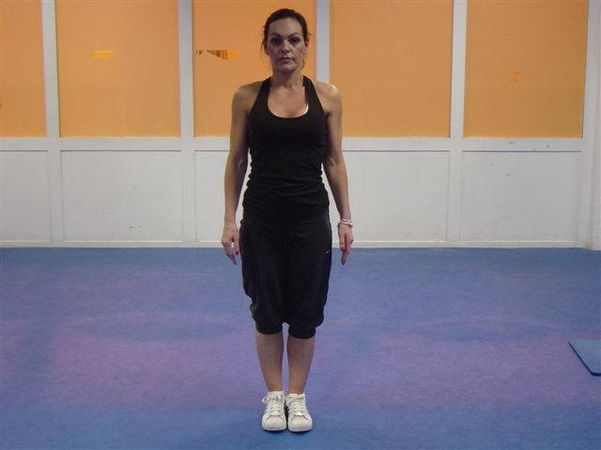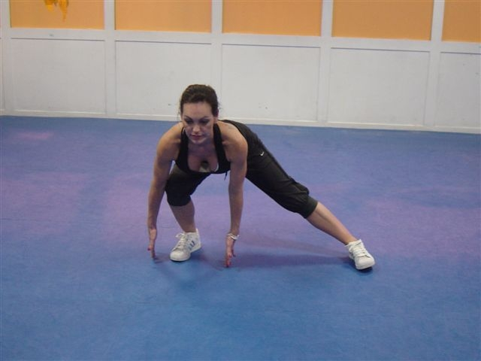

Plank Walk Up
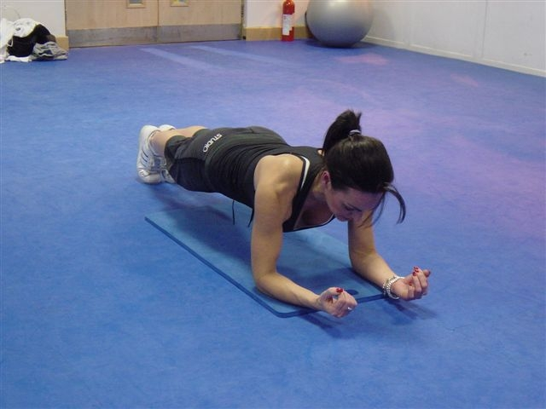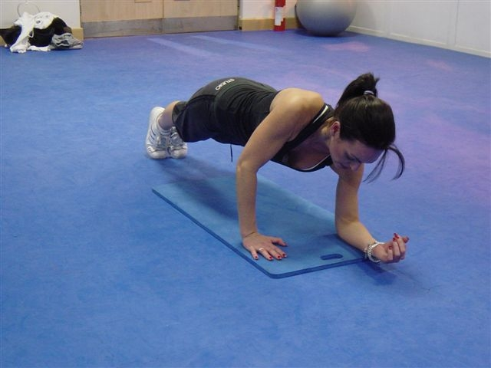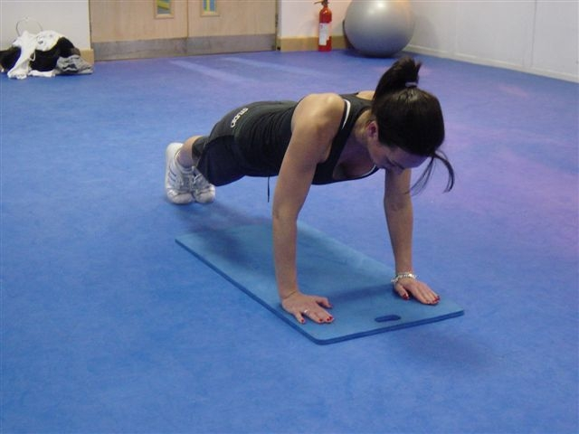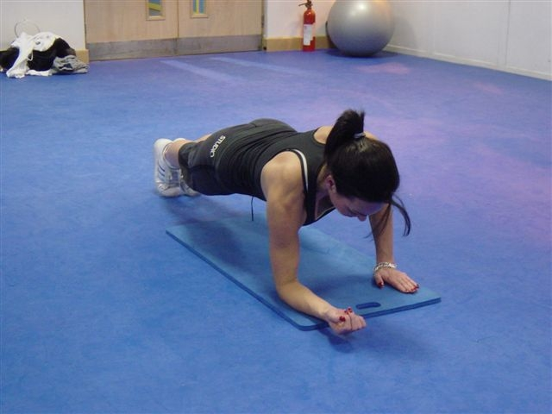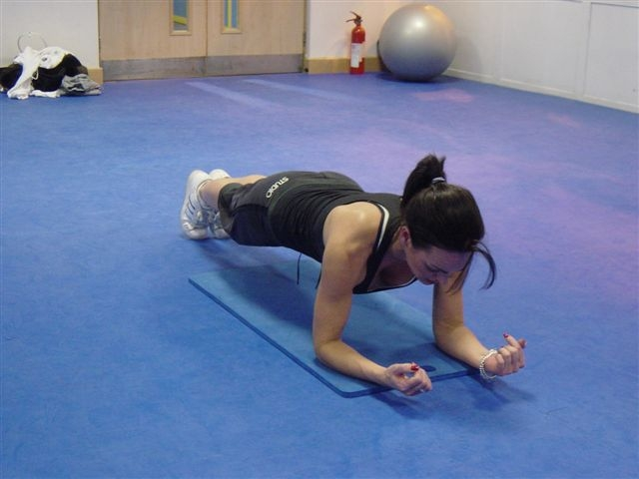
Power Squats
From a squat position, jump and land back into the original position. Make sure that you cushion the landing.

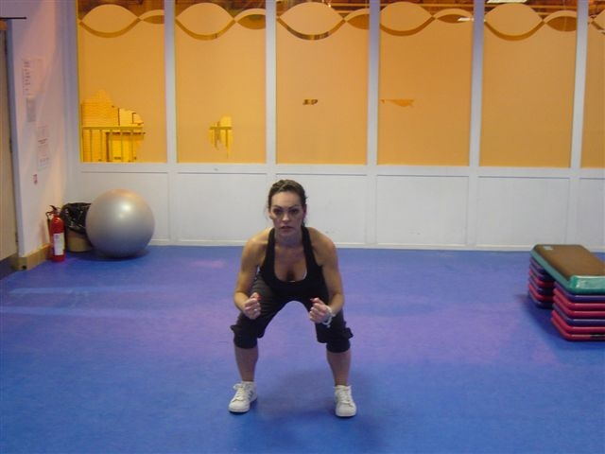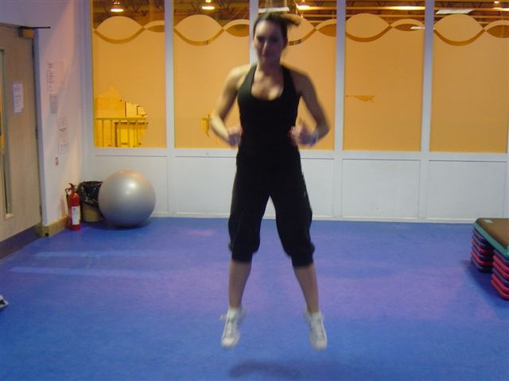

About the Author



Lincoln is the author of “Crack The Weight Loss Code” and has his own business, MEPTAcademy, as well as a BSc degree in Recreation Management and Sports Science. He has been involved in the fitness industry for 32 years and has presented fitness and aerobic sessions all over the world, including Italy, Spain, Holland, Germany France, Hong Kong, and Mexico.

Linx has toured the UK presenting his unique stylised sessions, and is the creator of 20 fitness videos. In between organising his own fitness and dance days, he had his own TV Slot on the popular Big Breakfast TV Show, teaching streetdance fitness.

He currently works as a lecturer at Midkent College, and was the first instructor in the UK to gain the CYQ Level 3 Advanced Studio instructor award.

He is the European Master Trainer for Metabolic Effect Hormonal Fat Loss, and is a certified personal trainer and nutritional consultant.

